Linda Solis
Due Feb 24th
Planning Analysis Sheet ----------------------------------------→10 points
Planning Analysis Sheet: Create document for review to proceed to the next
phase. Include the following headings:
Web Site Goal
Describe the goal of your web site in one or two sentences.
The goal of my web site is to create a craft store that reflects a reliable working site that keeps clients engaged and attracted and collects data. But the primary focusses it to learn to build a clean, complete, and organized website code to obtain the knowledge and expectations.
What results do I want to see?
List the working title of each page on your web. You will have six to ten working titles listed.
Home | About Us | Products | Contact Us | Support Us | Careers

What information do I need?
List where you will obtain the content (facts, text, graphics, sounds, and video) for the web pages you listed above.

Home | - Facts: description on what the store sells and offers and how it apports to the world and the impact within our clients also build a popup subscription box to collect leads.  - Text:  - Graphics: my own actual pictures  <h1: title and brand name image  I would like to add  - Sounds: no sounds  - Video: my own
About Us | - Facts: company and owner own bio on how it started as a hobby when I was 15 years old and now it is an actual small business and include vision and mission and values statements  - Text:  - Graphics: my own actual pictures  - Sounds: no sounds  - Video: my own
Products | - Facts: quick description on size measurements, weight, characteristics, description, color, material, customized, add purchase policy maybe even add no cancelations allowed once order has been submitted and the expectations that a customized product takes up to 7 days to be completed before shipping  - Text:  - Graphics: my own actual pictures SOME product with slideshow that include video if possible  - Sounds: no sounds  - Video: my own  I am including some of the products I have hand made and will be including in my products  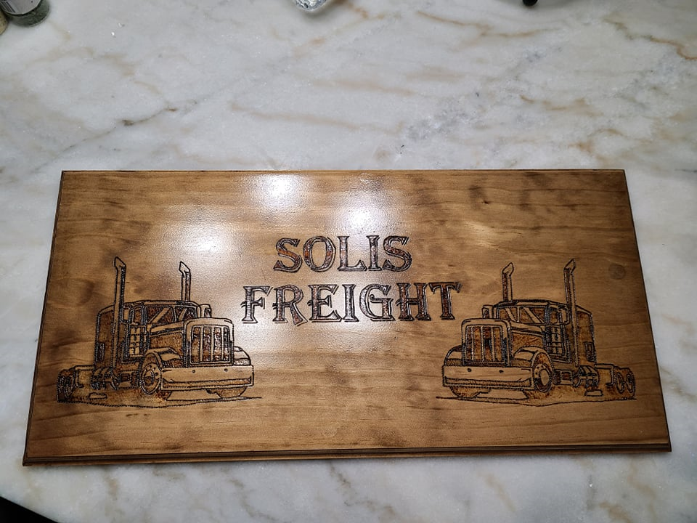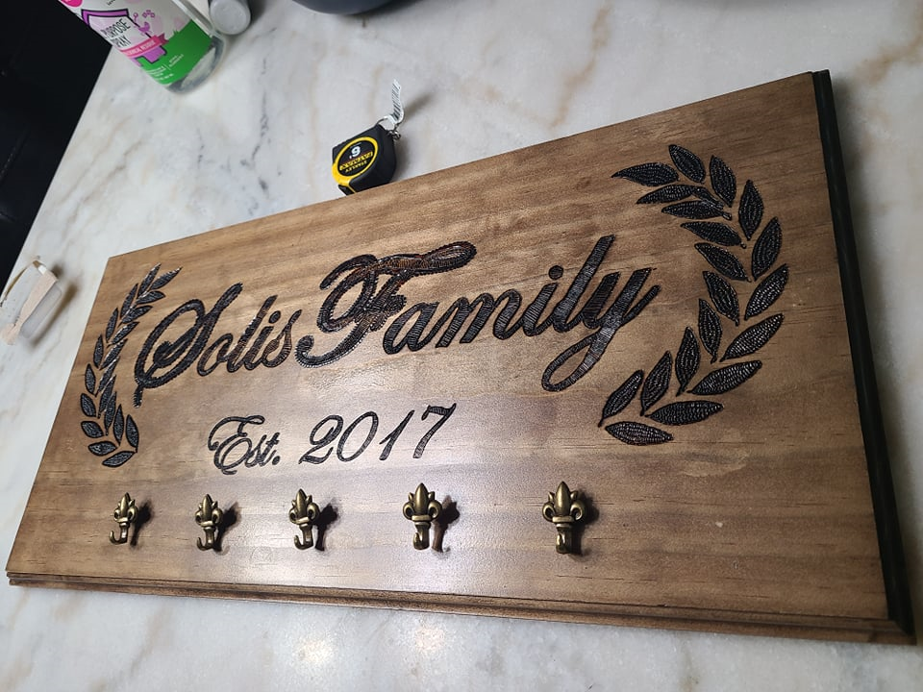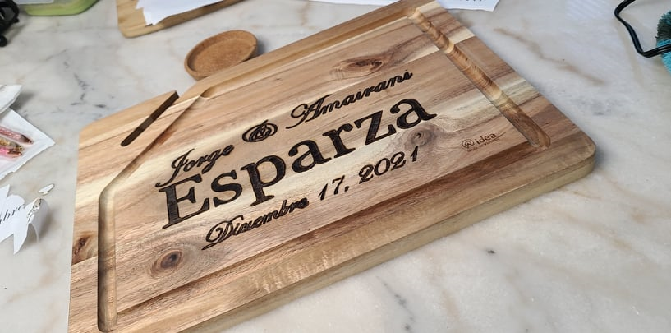
Contact Us | - Facts: explain how we can be contacted, expectations on how soon they will obtain a response, how to reach out, and all contact methods and social media alternatives  Facebook, email, build a form box to get contacted, not sure if a phone number. Also a form to provide feedback.  - Text:  - Graphics: my own actual pictures  - Sounds: no  - Video: no
Support Us | - Facts: reiterate vision and mission and values statements and its impact to the business and the people convincing them to donate  - build a form box to get contacted and provide email  - Text:  - Graphics: my own actual pictures  - Sounds: no sounds  - Video: no
Careers | - Facts: make up some positions that might be needed in a future and include a submitting form to apply.  - Text:  - Graphics: my own actual pictures  - Sounds: no sounds  - Video: no

How will your project use a form?
Describe how you plan to use a form in your project to collect information - examples of using a form might be to offer feedback, provide a survey or poll, offer subscriptions to a newsletter, etc.
- Career page, make up some positions that might be needed in a future and include a submitting form to apply
- Contact Us page, Users to provide feedback on web or product or anything
- On Home page, build a popup subscription to newsletters box

